

**CSC1300: LAB 11 – Library Book Genres**

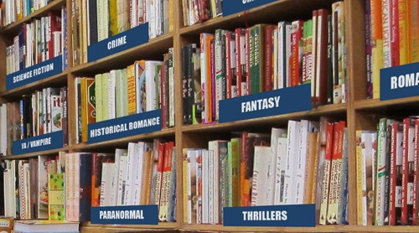

# Concepts

* Array of Pointers
* Dynamic Memory Allocation

# Description

The purpose of this lab assignment is to get you all more comfortable with using pointers and learning how to deal with an array of pointers. Your program is going to be storing data for four different libraries. Each library contains the same number of genres of books but may have a different number of books in each genre. A book genre is a category of artistic composition, characterized by similarities in subject matter such as science fiction, thriller, fantasy, crime, and romance. Your program will determine which library (and which genre) has the most books.

# Specifications

1. Name your program **lab11.cpp**
2. Define your variables. One of your variables should be an array named **numBooksArray** of SIZE pointers to integers. SIZE should be a global constant set to the integer 4 to represent the number of libraries. I drew a picture below to show you what this array would look like in memory.  
   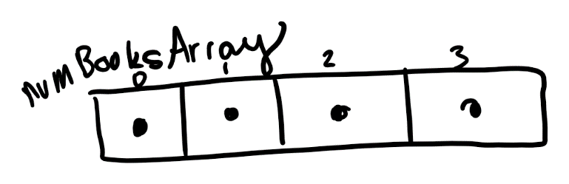
3. Ask the user how many genres of books does each library have and read this value in to an integer variable named numGenres.
4. Dynamically allocate an array for each library the size of numGenres. You can use a loop to do this.
5. Get input from the user and place the input into the correct library array. You will be asking the user to enter in the number of books in each genre. I drew a picture below to demonstrate what this could look like in memory after the user enters in the number of books for each library and each genre.  
   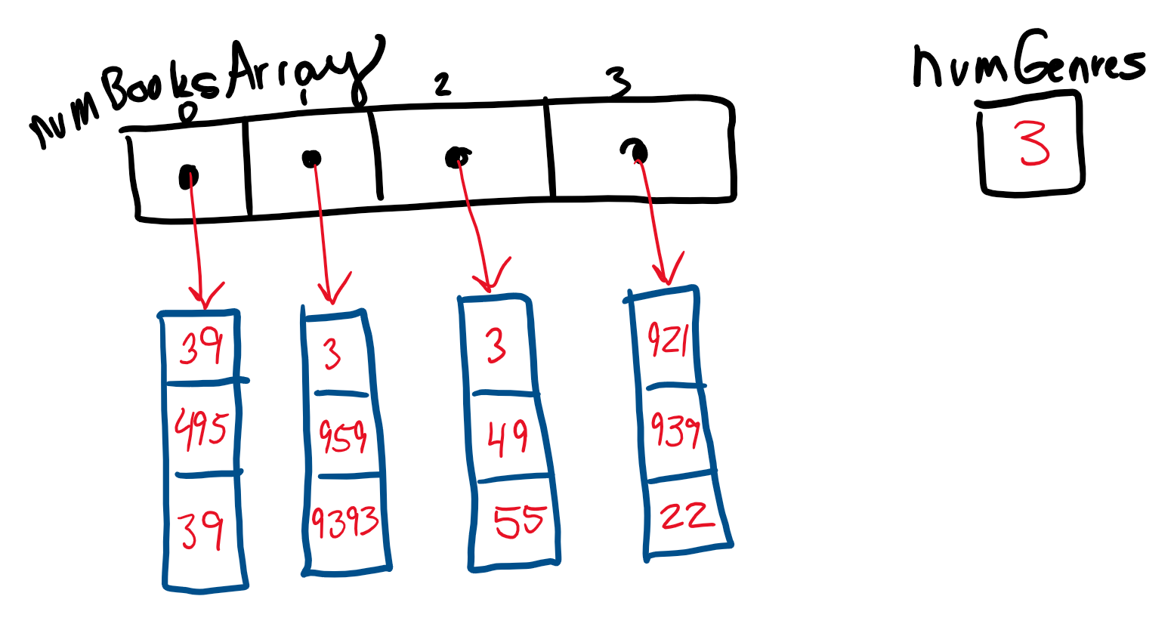
6. Get the largest number of books in any genre and then print out “LIBRARY [X] has the largest number of books in GENRE [Y] which contains [Z] books!!” where X is the library number (1, 2, 3, or 4) and Y is the genre number and Z is the number of books in that genre.  
   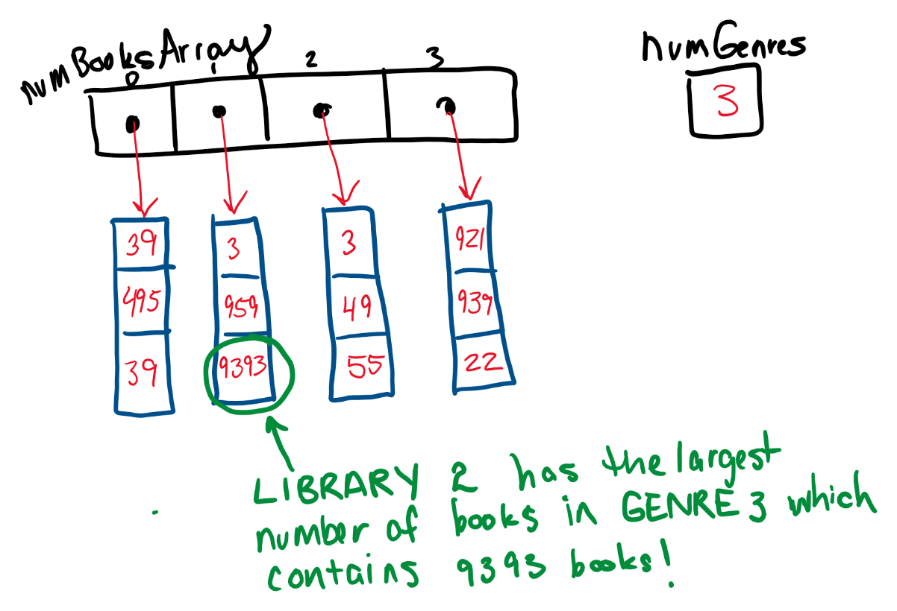

# Sample Output

How many genres of books do you have?

3

Please enter the number of books in each genre.

LIBRARY 1 GENRE 1: 39

LIBRARY 1 GENRE 2: 495

LIBRARY 1 GENRE 3: 39

LIBRARY 2 GENRE 1: 3

LIBRARY 2 GENRE 2: 959

LIBRARY 2 GENRE 3: 9393

LIBRARY 3 GENRE 1: 3

LIBRARY 3 GENRE 2: 49

LIBRARY 3 GENRE 3: 55

LIBRARY 4 GENRE 1: 921

LIBRARY 4 GENRE 2: 939

LIBRARY 4 GENRE 3: 22

LIBRARY 2 has the largest number of books in GENRE 3

which contains 9393 books!